West Hull Ladies
RRC

January
Newsletter

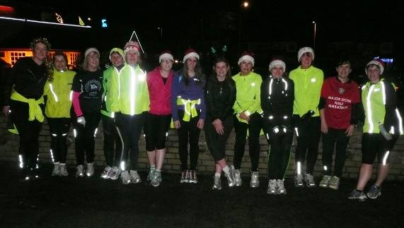

West Hull Ladies
Light Up the Streets ...

WEST HULL LADIES RRC
COMMITTEE MEETING

West Hull Ladies Committee Meeting 03/12/2012

Attendees:- Sandra Holdsworth and Ann Holmes

Minutes of Meeting Monday 3rd December 2012

Most members were unable to make the meeting due to other commitments and as such Ann and I discussed the only one item that needed discussion. This related to the timing of the advertising of the beginners runners course. It was decided that this could be left until after Christmas.

After the training session had finished we discussed cancelling the meeting with Jo whom we had met in the car park – this was agreed. All items on the agenda that hadn’t been dealt with to be added to the next meeting.

West Hull Ladies Committee Meeting 07/1/2013

Minutes of Meeting Monday 7th January 2013

Present Sandra, Amanda, Debbie, Maria, Jermaine, Sally, Ann, Verity, Shem

- Apologies were received from Annette, Jill, Geri, Victoria and Louise.
- Ref the letter received a while ago asking if we would be interested in hosting YVCC championship in 2014 – discussed and agreed did not have resources to do this so the answer was No.
- Minutes of meeting held on 3rd December were agreed by Sandra and Ann.
- Discussed beginners course and Weeks 1 and 2 were allocated trainers and buddies. All trainers’ buddies and beginners were to wear name badges to help identify each other. Amanda was to formulate a welcome letter to be sent to all beginners prior to the course commencing. This would give details of where to meet (lounge of YPI) – suggested clothing, nutrition etc. It was reiterated that the start time for each night would be 6.15pm. Members agreed that the course would develop as it went along and feedback was received from the participants.
- Debbie (new Treasurer), Sally (Secretary) and Maria (Kit lady) updated as to how respective handovers were going. Debbie was still awaiting news from the Bank, Maria was to liaise with Geri and Sally was in the process of arranging a meeting with Louise.
- Amanda updated the meeting as regards the Chair Jo resigning and Jill taking over until the AGM when all posts would be open to members of the club. Everyone wanted to thank Jo and wish her well hoping that she would return to the club in the not too distant future.
- Due to the way Easter falls this year it was provisionally agreed that the AGM would be held on 22nd March 2013. Katy as the social secretary would be contacted by Amanda to discuss arranging the function room etc.
- AOB. Amanda had prepared a sheet(s) detailing the different roles within the Committee and the responsibilities relating to each role. She would email these out to the committee. Amanda also informed members of a Nutrition Workshop that was to be held on the 5th Feb between 1830-2030hrs at the Octogon in the City Centre. This workshop is free but donations of £3.50 per person requested by HAN (Humberside Area Network).

The Meeting then closed.

Running Lingo

Ever wondered what that running word meant?
Here’s the answer (Source Running World)

10-K pace 10-K pace, when used in a workout to describe how fast to run, is simply the pace of a runner's last 10-K race. "10-K pace" is therefore different for every runner, for Paul Tergat, it's 4:16 per mile.
5-K/8-K/10-K K is for kilometers, 1,000 meters. A 5-K is equal to 3.1 miles; 8-K is 4.96 miles; 10-K is equal to 6.2 miles.
400 meters Equivalent to a quarter mile or 1 lap around a standard track.
Aerobic Used to refer to running or other exercise at an intensity that's sufficiently easy for your respiratory and cardiovascular systems to deliver all or most of the oxygen required by your muscles, and slow enough that lactic acid doesn't appreciably build up in your muscles. Generally, you can sustain a slow aerobic pace for long periods of time, provided you have the endurance to go long distances.
Anaerobic Used to refer to running or other exercise at an intensity that makes it impossible for your respiratory and cardiovascular systems to deliver all or most of the oxygen required by your muscles, and fast enough that lactic acid begins to build up in your muscles, thus producing a tired, heavy feeling. The pace associated with anaerobic running cannot be sustained very long.
Anaerobic threshold (AT) The transition phase between aerobic and anaerobic running. Good training will increase AT by teaching the muscles to use oxygen more efficiently, so that less lactic acid is produced. Also known as "lactate threshold."
Bonk See "hitting the wall."
Chip time A technology for sensing and recording the finishing times of all the runners in a race. It's much more accurate and can easily deal with the old problem of many runners finishing nearly at once in a big, crowded race. The "chip" is a tiny electronic chip that's programmed with your specific runner identification. You attach the chip to your shoe laces. It sends a signal to an electronic reading device--often hidden under a strip of carpet-- when you cross the start line and again when you cross the finish line. No human observation is necessary. Your exact time is recorded automatically. Usually you are asked to turn the chip back in to the race organizers.
Cool-down Slow running or jogging done after a workout or competition to loosen muscles and rid the body of lactic acid.
DNF Did not finish.
DNS Did not start.
DOMS Delayed onset muscle soreness. This type of muscle soreness normally peaks about 48 hours after a particularly intense or long run.
Dynamic Stretches Stretches performed during a warm up that use speed of movement, momentum and active muscular effort to bring about a stretch. Unlike static stretching the end position is not held.
Fartlek Swedish for "speed play;" variable pace running; a mixture of slow running, running at a moderate pace and short, fast bursts. Fartlek training is a "creative way" to increase speed and endurance.
"hitting the wall" The dreaded point (and awful feeling similar to what your body would feel like if you ran into a wall) during a race when your muscle glycogen stores become depleted and a feeling of fatigue engulfs you.
Intervals Training in which short, fast "repeats" or "repetitions" are alternated with slow "intervals" of jogging or complete rest for recovery; usually based on a rigid format such as "six times 400 metres fast [these are the repeats] with 400-metre recovery jogs [the intervals]," interval training builds speed and endurance.
Junk miles Runs at an easy pace inserted into a program in order to reach a weekly or monthly mileage total rather than for any specific benefit. Despite the name, "junk miles" often serve as recovery from harder workouts. The value of "junk miles" is still hotly debated among training theorists.
Lactic acid A substance which forms in the muscles as a result of the incomplete breakdown of glucose. Lactic acid is associated with muscle fatigue and sore muscles.
Lactate threshold See "anaerobic threshold."
LSD an abbreviation for "Long, Slow Distance," which refers to the practice of running longer distances at an "easy" pace rather than shorter ones to exhaustion.
Marathon 26.2 miles; According to legend, in 490 B.C., a Greek soldier name Philippides ran the distance from the site of the battle of Marathon to Athens, where he died after the Greek victory over the Persians.
Maximum heart rate The highest heart-rate reached during a specified period of time.
Negative splits Running the second half of a race faster than the first half.
Overpronation The excessive inward roll of the foot before toe-off. Overpronation is believed to be the cause of many running injuries.
Pick-ups Accelerations done during a run, normally done in shorter durations than fartleks. Pick-ups are simply another way to spice up what would otherwise be an easy-run day.
Plyometrics Bounding exercises; any jumping exercise in which landing followed
by a jump occurs.
Pronation Pronation begins immediately after the heel contacts the ground. It is a normal and necessary motion for walking or running. Pronation is the distinctive, inward roll of the foot as the arch collapses.
PR/PB / PW Personal record/personal best / personal worst
Runner's high A feeling, usually unexpected, of exhilaration and well-being directly associated with vigorous running; apparently related to the secretion of endorphins.
Running economy Refers to how much oxygen you use when you run. When you improve your economy, you are able to run at a smaller percentage of max VO2 (your maximum rate of oxygen utilization).
Splits Refers to your times at mile markers or other pre-planned
checkpoints along the way to the finish line.
Static stretches Stretches that stretch muscles while the body is at rest, usually at the end of a run when the muscles are warm. They gradually lengthen a muscle to an elongated position and that position is held.

Strides Short, fast, but controlled runs of 50 to 150 meters. Strides, which are used both in training and to warm up before a race, build speed and efficiency.
Supination The opposite of pronation. It's an outward rolling of the forefoot that naturally occurs during the stride cycle at toe-off. Oversupination occurs when the foot remains on its outside edge after heel strike instead of pronating. A true oversupinating foot underpronates or does not pronate at all, so it doesn't absorb shock well. It is a rare condition occurring in less than 1 percent of the running population.
Taper Runners usually cut back mileage (or taper) one day to three weeks (depending on race distance) before a big race. Tapering helps muscles rest so that they are ready for peak performance on race day.
Target heart rate A range of heart rate reached during aerobic training, which enables an athlete to gain maximum benefit.
Tempo runs Sustained effort training runs, usually 20 to 30 minutes in length, at 10 to 15 seconds per mile slower than 10-K race pace. Another way to gauge the pace of tempo runs: a pace about midway between short-interval training speed and your easy running pace. Sometimes called a ‘pace run’.
Threshold runs Runs of 5 to 20 minutes at a pace just a little slower than your 10-K racing pace; Threshold pace is roughly equivalent to what exercise physiologists call "lactate threshold," or the point at which your muscles start fatiguing at a rapid rate. Running at or near lactate threshold is believed to raise your lactate threshold, which should allow you to run faster in the future.
Underpronator Underpronation is less common than overpronation. The shoes of underpronators show outsole wear on the lateral (outer) side not just at the heel but all the way up to the forefoot. Typically, underpronators tend to break down the heel counters of their shoes on the lateral side.
VO2Max (maximal oxygen consumption) The maximal amount of oxygen
that a person can extract from the atmosphere and then transport and use in the body's tissues.
Warm-up Five to twenty minutes of easy jogging/walking before a race or a workout. The point of a warm-up is to raise one's heart rate so the body (and its muscles) are looser before a tough workout begins.

Evil Sheriff Duathlon

Jill

Duathlon (5k trail run; 16k off road mountain bike course; 3.6k trail run)

I'm not quite sure how I got myself into this event, but it seemed like a good idea at the time. I had been searching on the internet for triathlons and duathlons, because I fancied having a go at a multi event and I came across the 'Evil Sheriff Duathlon' at Sherwood Pines Country Park. Having enjoyed riding my mountain bike around there a number of times, and having bought myself a cheap tri-suit from Aldi, I jumped at the chance to enter.

Then I started to have serious second thoughts! On reading the literature more carefully, I noticed references to technical mountain bike tracks, adrenaline rushes, and the fact that the race would live up to its 'evil' title!!!...So I got more and more panicky the closer the event got. In preparation I went out to the Waudby Green area and cycled up and down the hills getting absolutely covered in mud...so bad that my tyres turned into mud slicks and I found I was going backwards down the hills. The purchase of some better mud repellent tyres and some more practice, gave me a bit more confidence and I kept trying to tell myself it can't be that bad surely!

I then started to do a 3k run straight after getting off my bike....ouch....bring on the wobbly legs and tight calf muscles...and also panic now turning to near hysteria! Apart from this I initially had difficulty even getting into the tri-suit which is an all in one suit...not because I'm too fat, because its quite stretchy, but because I could initially only get either into the top or the bottom, but not into both ends at once! Zoe thought this was hilarious and suggested that I climbed into the suit through the neck which of course worked ... Duhhh!

The day of the event came with my alarm set for 5.30am as the event start was 9am and I had to drive the 70 miles to the event ... but I was wide awake well before this, so got up. After my Weetabix, cup of tea and glass of juice, I packed everything in the car. Anyone would have thought that I was going away for several weeks the amount of luggage I had with me ... but I'm the sort of person that has to carry things for all eventualities with me ... so I had clothes, food and bike tools for all seasons, disasters etc!

On arriving at the event, my anxiety got worse after being surrounded by lots of men with mega-expensive hi tech mountain bikes, but one cup of tea and a cereal bar later, I felt ready to go. Getting my trusty little GT hardtail (mountain bike with front only suspension) out of the car, I deposited it in the transition area, with a plastic lidded box (as Ann had given me some good advice about covering your shoes etc in case it rains whilst you are doing your first event). Whilst multi event pro's use special cycling shoes, so have to change between their running and cycling shoes, I am not that hi-tech and tend to run and ride in my trail shoes so my box only contained my helmet, protective glasses, a drink and some Jelly Babies and an opened fruit bar.

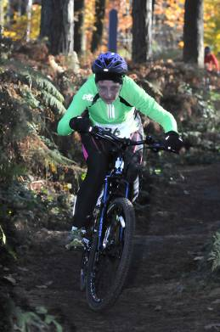
8.45am came around with a briefing about the route. Yellow arrows for the run and orange ones for the two lap bike ride, then all too soon we were off on the first 5km run. I had originally decided to run in my long sleeve top and running tights underneath my tri suit, but also started in my lightweight jacket .... bad decision ... will I ever learn? Within minutes I was too hot even though it was only 2 degrees with frost on the ground! I was able to open up my jacket so it was not too bad ... but I ought to know by now that when I am competing that I should wear less clothes then I think I should! The course had some hills on it but the ground underfoot was sandy, but quite nice to run on. My time was a bit rubbish at 28:03, but I wanted to keep plenty in reserve. My transition time was 1:35 ... not quite sure where the time went but made sure that I got my helmet and gloves on before I grabbed my bike, as I didn't want a penalty.

Quick swig of drink and a handful of jelly babies later and I was off again, this time on the bike. The man in front of me got a penalty for scooting his bike in transition (a big no no apparently). The bike course that I had been worrying about for weeks, proved to be such a buzz. It really wasn't as technical as had been suggested. There were some of the down hills where I didn't feel totally in control, but that was because I had been going a bit quicker than I would have done normally. It was a case of aiming the bike and hoping for the best on the wet leaves. I surprisingly found myself going past quite few people on this part of the event, in fact the only person to come past me was a fast man who had to stop to mend a puncture. At one point I came across a poor man who was riding his bike with a loose seat (ouch!), which made me glad that I had tightened every nut and bolt I could see on the bike. The second lap on the bike, seemed much easier as I remembered how to ride the tricky bits.
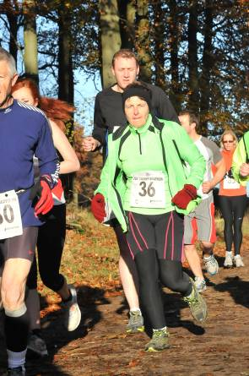
All too soon I was heading for transition once again...as I jumped off the bike before the line, my legs felt as if they had stopped working...I actually thought that I had forgotten how to walk!!! Limping to my place in the area, hanging onto my bike for grim death, I then hung my bike up, got rid of my helmet and wondered how I could get my legs to work again. I run-walked out of transition and then started to run more fluently, unfortunately, my calves started to really cramp up, so I had to stop and stretch them. I started running again and was relieved to find that my legs seemed to be okay. I decided that the best policy was to make sure I finished as I wanted to make sure that I got my T shirt! The 3.6kms seemed to go quite fast, and soon I was relieved to be coming up the finishing straight.
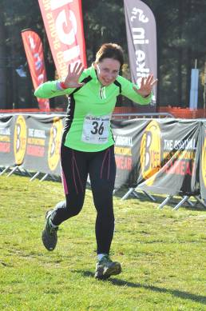
My finishing time was 1 hour 54 mins: 10 secs, which I was really pleased about as I was hoping to be around the 2 Hour mark. I wasn't last which was good, in fact I was 20th Woman out of 36 (and one of only 3 over 50's), and 248th competitor out of 302. My bike time was 1 hour 3 minutes, and the second run was 19:55 with a second transition time of 1:40. The overall event was really well organised, with runs at 10k, 5k and 2k taking place after the duathlon. Definitely going to do this again next year, and now I want a road bike to have a go at some more duathlons...and perhaps even a triathlon...if I can learn how to swim better!!

West Hull Ladies Cottingham Lights Run

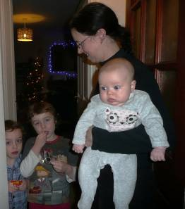
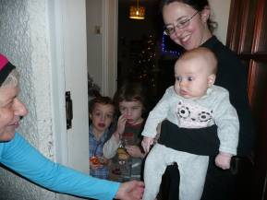

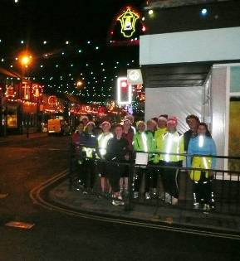

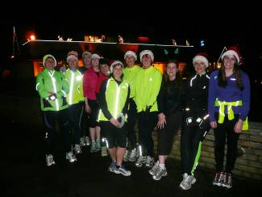

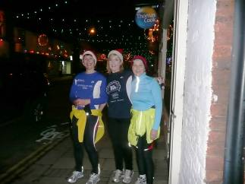
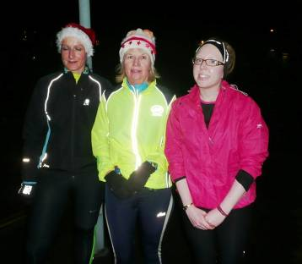
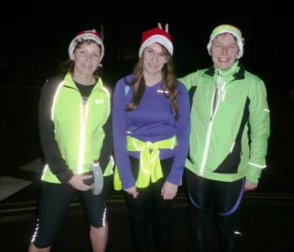
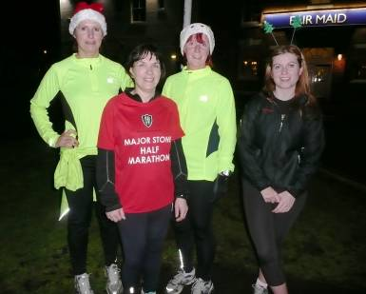
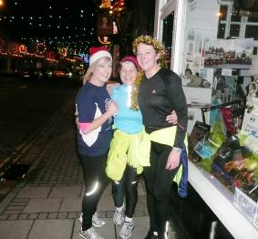

Hillforts and Headaches New Year Race

Amanda

New Year Day found me in Rothbury, Northumberland with 5 friends preparing for a three mile fell race. This would be my second fell race and it promised to be uncomfortable as it was a 3 mile uphill race finishing on the top of Beacon Hill. My friends are 4 Bingley Harriers who are all used to fell runs plus Len from Nottingham who is as far from hills as you can get (at least we have the Humber Bridge). The day was bright, cold and very windy and I was well wrapped up and sorry to leave the comfy Newcastle Arms which was the race head quarters.

We set off down a narrow alley and over the river then uphill first on road, then track and then fields. We had a bit of bog hopping and some heather bashing to add variety but generally good underfoot. There was a fair section which was gently uphill where you almost longed for the steep sections where you could have a legitimate excuse for walking. Eventually we reached a top and had a lovely descent to a car park at which point, having mistaken for the end of the race, I upped my pace in anticipation of it all being over. I was utterly disappointed when we were pointed through the car park to a very steep path to a peak which seemed a seriously long way off and a lot higher.

A real slog now and I think I eased up a bit just because I couldn’t hack the pace I was doing any more. The wind was cutting across us now and with my mouth open gasping for oxygen I found my left cheek was flapping in the wind, not pretty however the only thing I cared about was stopping and that wouldn’t happen until I was at the top of the mountain (did you note how the hill was suddenly a mountain). I made it and quickly pulled on my wind proof and ducked into shelter. Once all 6 of us finished and the photo taken we quickly headed back down to stop chilling off.

The trot back to head quarters was lovely with beautiful views over the valley and run at an enjoyable, steady pace.

Back at the Newcastle Arms we were provided with soup and really pleased and surprised when the presentation occurred to find that 5 of the 6 of us received prizes (bottles of wine) for 3rd lady, 5th man, 1st FV50 (me), 2nd FV50 and 1st V60. Amazing.

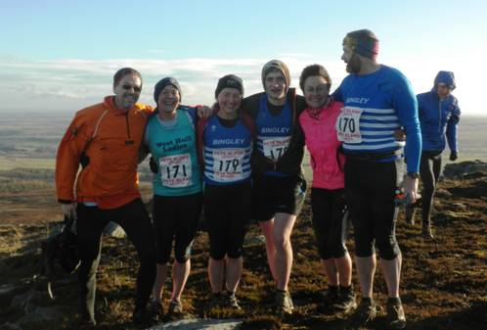

Race finish top of Beacon Hill

Full results:
http://www.northumberlandfellrunners.co.uk/html/raceresults/2013/HillForts13.html

It was a really friendly atmosphere and if you are in the area at New Year I would definitely recommend it.

Just in case you were curious: I was staying at Wooler YHA with 27 friends / family members. Yes we ate and drank too much on New Year’s eve and stayed up late bringing in the New Year singing Auld Lang Syne and dancing to a mandolin and accordion!

EHH Boxing Day 10k

Sandra

This Christmas I had family over including my niece Vicky who is just getting back into training after being injured. Before she came she asked if we were out running on Christmas Day. Whilst I did go out early Christmas morning she didn’t come over until mid morning – too late for me. So I suggested that we ran Boxing Day together and how did she fancy the East Hull 10k. She was really keen to do this so we entered on line so there was no backing out.
We had plenty of support bringing my parents, sister and friend to cheer us on.

Prior to the race I had tried to find the route but couldn’t so I was pleasantly surprised once we set off. It followed the first part of the East Hull 20 – flat, flat flat – wonderful.

It wasn’t too bad a day and the wind was behind us for the first half. I ran with Vicky trying to spur her on but she confessed at the end that I was starting to get on her nerves! As we turned after about 3 miles we hit the wind full force – open countryside with no shield. I went in front to try and protect her a little. After running along the old railway line which was lovely the last mile was on the estate. The only good thing about this was that the last half mile was down hill.
I have to say that I really enjoyed the run and am not sure if it was because I ran with Vicky or the fact that I didn’t have to go flat out and could just enjoy. I will definitely do it again this year – just nice to be out after a hectic day indoors on Christmas Day.

Sandra

Rudolph Romp

Amanda
The most remarkable thing about the Romp this year was how many ladies made it round the 17 mile recce, most of whom had not run more than a half marathon before that day. Most took that as a great achievement and left the Romp as ‘something for the future’, not Zoe! She was there at Brantingham Village Hall, nervous, but ready to go. Jill there too but disappointed that she had to drop out with a bad cold and, even at the end when we were complaining about how much it hurt, she looked very jealous.

When I arrived at the Hall there were Verity, Zoe and Jo (with her firemen) ‘ready for action’. I was not feeling very well trained for this but could not complain as I was most trained up of all of us. It had been raining during the week but today was dry and below freezing which meant that the roads and hard surfaces were very icy. Added to this the muddy, sheltered sections through the woods were even muddier than usual!

Anyhow, off we went, Jo with her firemen and Zoe and Verity as a team. I trotted along at my pace and in no time at all was walking up the hill to Mount Airy. A chap was desperately whistling for his dog who had raced off in the excitement of being out with the biggest pack he’d ever encountered. They were reunited quite soon but by a very angry farmer who was clutching the little brown spaniel. Oops. Dog well controlled after that. Next we slid down the muddy, frosty hill then skated through South Cave before the next climb and the drop into Drewton estate. It was nice to arrive at North Cave feeling fresh. Last time I was here I was on my last legs!

Started taking in some food at this point and continued every couple of miles to consume a little more. Sancton, with its massive kettles on the stove and lovely looking scones, was very inviting but standing around would not have done me any good so I just topped up my bottle and carried on. It was extremely icy in places so it was a relief that after the Arras Farm self clip the road was OK. Trotted on and before long reached the ‘Pig Farm check point’ where I was beginning to tire but, not too bad. I managed more food through the long valley. Looking forward to reaching High Hunsley where I pretend I am nearly there because there is some downhill ahead (mad mind games). Chatted to various people as I went along but left them behind as I stretched out on the downhill through Drewton Estate. Soon walking though as we hit the climbs. Good to reach the lovely woods which sweep down ‘bench hill’ before reaching South Cave. Now, I had had enough! 3 miles to go and I knew I would make it, but not enjoy it. Just keep it going.

Arrived in the village hall and, after a minute of gasping, the lady told me to sit down before I fell down which prompted me to stop being a drama queen and go get some food and drink. I walked back up the hill (slowly) and did a bit of stretching to get my legs moving. Saw plenty of distressed runners who were keen to know ‘how far’ then Jo appeared having run a very good time. Chilling off so back to the hall where I sat with Jo and her firemen, then Jill, then Zoe arrived saying “Never again!” ... and later told me “but I sprinted in.” Simon there too, waiting for Verity who arrived shortly after having run a PB marathon on a non-PB day!

It is tough, and the last few miles are simply to be endured but, it is a wonderfully well organised event with beautiful scenery and I shall no doubt be back next year. Join me?

Zoe

So, finally I have got round to writing about the Rudolph Romp. It may have taken me this long because I have been busy with work. However, the more likely excuse is that I wanted to erase all thoughts of the Romp from my memory.

It was a very cold Saturday morning when I awoke very nervous and not really looking forward to the run. I knew that I was very under prepared and was wishing that I had done more training. The night before I had asked Verity to run with me and the thought of having someone there to chat with made me feel a lot better.

On arrival, I nearly fell out of the car onto the ice because it was incredibly slippery, which didn’t bode well for the road sections of the Romp which are meant to be the easy bits! The roads were like ice rinks and the fields were like swamps and this tired us out and slowed us down. However, we did manage to giggle away the first 17 miles and despite the wet feet I was actually quite enjoying myself.

It all went downhill from this point…….well…….I suppose what I actually mean is UPHILL! Running (or should I say staggering) up towards High Hunsley I believe we had both had enough. I remember saying to Verity “can I give up yet?” to which she replied “don’t you dare stop now.” The conversation dried up as we tried to conserve energy for the last three uphill sections. We reached the bottom of the sheep field (only about 4 miles to go) were I lost Verity and I carried on up the hill. I suddenly felt like I had found some energy and ran all of the way up the hill. I think it was because I was suddenly passing all of these tall men who were struggling to walk up the hill. Picking them off one by one helped keep me going. I took a short drink break at the top of the hill before enjoying the downhill section (trying not to fall flat on my face as my legs felt like jelly). I actually enjoyed this section knowing that I was nearly home, however there was still the dreaded ‘Steep Hill’ to come. I decided to walk all of the way up steep hill, it was just far too steep to run up on tired legs. The last 2-3 miles felt so long and I was getting very cold. When I saw the village hall signalling the finish line I was so happy that I had to put on one final sprint to get there faster. I stopped my watch at 5 hours 5 mins. The 5 minutes was just a little annoying! When Amanda asked me how I found it, all I could say was “NEVER AGAIN!”

In hindsight, it was a very good experience. If the conditions had been better I may have enjoyed it more. To answer the question: Will I ever do it again?
Probably! After all, I need to run it in under 5 hours.
Racing and Running Events

Date | Event | Distance | Fee | Entry / website
January 2013
20th 10.00 | Brass Monkey | ½ marathon | - | Full
27th 11.00 | Ferriby 10 | 10 miles | £11 | Entry form
February 2013
10th 11.00 | St. Wilfrid’s Muddy Boots, Ripon | 10k | £10.10 | Entry form
10th 11.00 | Caythorpe Dash (off-road) | ½ marathon | £10 | Entry Online
24th 11.00 | Snake Lane 10 | 10 Miles | £12.50 | Closed!
March 2013
17th 10.00 | East Hull 20 | 20 miles | £18 | Entry form
April 2013
17th 10.00 | Hornsea Third | 8.74 | £10 | Entry form
15th 8.00 | The Woldsman | 50 miles | £17 | Entry form email to eyldwa_entries@btinternet.com
28th 9.00 | N.Lincs ½ | ½ marathon | £24 | Enter online
May 2013
19th 9.00 | Jane Tomlinson Hull | 10k | £20.12 | Enter online (when open)
July 2013
14th 9.30 | Jane Tomlinson Leeds | 10k | £20.12 | Enter online (when open)
Aug 2013
4th 9.30 | Jane Tomlinson York | 10k | £20.12 | Enter online (when open)

East Hull Harriers Winter League
East Hull Harriers would like to invite WHL club members who would like to run in any of the East Hull Harriers 2012/2013 winter league. You will not feature in the league itself but can take part in the races
There is no entry fee just turn up on the day
Any further information ring John Baker on (01482) 824648.

Saturday 16th February 2013 – Riverbank Run
Distance: 6 miles (staggered start)
Start Time: 2.10pm Terrain: Riverbank Footpaths
Venue: Ennerdale Leisure Centre, Sutton Road, Hull
Friday 29th March 2013 – Good Friday Hill Run
Distance: 7 miles
Start Time: 10am Terrain: Footpaths & Hills Venue: Elloughton
Thursday 11th April 2013 – Paull Run
Distance: 5.7 miles
Start Time: 7pm Terrain: Riverbank Footpaths Venue: Paull Lighthouse
Check EHH website for all up to date information: www.easthullharriers.com

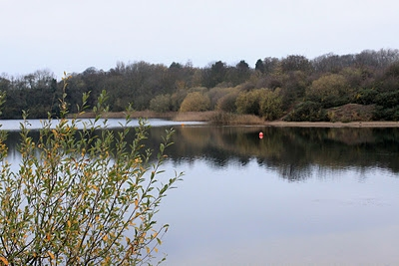
Try a Tri?

Sprint Triathlon - 9th May
Burstwick - Open water swim 750m (see picture), 20k bike, 5k run – Facebook link

Olympic Distance - 13th July
Ripon – have a look at the promo video

Children’s Triathlon – 8th June
Rother Valley - 150 metres swim / 4km cycle / 1.2k run
Check out the website here – this is a whole weekend of triathlon, including a ladies only sprint event

Keep checking the website for new races and updates: www.westhullladies.org.uk/races.htm Verity, Racing Officer

NOTE: Club Vests must be worn at any races you enter
under the West Hull Ladies running club name.

And finally ...

Ann’s training for Ironman – Report #1
Some ladies have been asking about my training, so I thought you might be interested in a little summary ...
What is Ironman?
Its a 2.4 mile swim, 112 mile cycle and then a marathon. Some events of this distance are official Ironman branded events (with a price tag to match), while others, including Outlaw, are the same distance but with different organisers.
It starts at 6 am with an open water swim, then the bike leg must have started by 8.15. There are 8 hours to complete the bike leg, and the final marathon cut-off is 16 hours later, at 11pm. Traditionally a very enthusiastic crowd stays until the last finisher crosses the line.
Why Ironman?
I really like running, but am worried about too much impact exercise and a dodgy knee. I guess triathlon is like the ultimate cross training for a runner, and I like a challenge! Plus, more exercise might at some point mean trimming down a bit more!
What does the training involve?
3 swims, 3 runs, 3 bikes, one of which is a brick session, where I run straight after the bike for 15 mins. There are 3 phases of 10 weeks, and I am currently starting week 6 of the base phase, which is about building an endurance base, so just easy pace training (apart from the swimming, which feels pretty hard going, to me, anyway!). This week I have 10 hours of training. In the next phase I start to add faster intervals into the sessions, and the long bike and long run sessions get longer, obviously!
The key differences for me with this plan, apart from doing cycling and swimming, is that I am training with a heart rate monitor, and to time, not miles. This is designed to keep me from working too hard when, say, I’m not well and its harder work to maintain my normal pace. Its also ensures I’m training aerobically rather than anaerobically, which is important on the day itself, because aerobic exercise uses a different system of energy within the body that lasts longer than anaerobic exercise, which should mean I can keep going for hours on end!! (At least that’s my simple interpretation of what seems to me to be quite complicated science.)
How do I find the time?
Don Fink’s ‘Iron Fit’ book advocates 1 hour training sessions (apart from the long run and long bike sessions), so I’m only ever looking for an hour at a time. At the moment I have three early starts, and some sessions are fitted in before tea. Sometimes it means a later tea. After tea only a last resort. Later on when I have 4 and 5 hour bike rides I may be getting up very early, or cycling after work and missing tea (not the preferred option!). I’ll cross that bridge when I come to it.
What’s my background that has prepared me for this?
For those who don’t know me so well – I’ve been running for two years, have cycled to work a bit, and last May could do 1 or 2 lengths of front crawl. Last year I did two marathons and really enjoyed myself, and realised that its the longer events I enjoy more.
After reading a couple of books - Chrissie Wellington’s ‘A Life Without Limits’ and Andy Holgate’s ‘Can’t Swim, Can’t Run, Can’t Bike – Common Man to Ironman’, I was inspired to try a couple of triathlons, and amazed myself how quickly my swimming improved, and how swimming in a lake was actually much, much more enjoyable than in a pool. I also found a community of like-minded crazy nuts on a Runnersworld online forum – the Pirates ... and, well, thought it won’t hurt to tri, will it?
... although I expect it probably will!

Clubwear
PRICES:
Vest | £16.00 | All items are ordered on request and must  be paid for at time of ordering. To place an  order please get in touch via West  Hull Ladies e-mail and mark your emails  for the attention of Maria.
T- shirt | £16.50
Hoodie | £14.00
Jacket | £32



New Club Jacket available in three sizes: small, extra small, and junior (large fitting). If you would like to purchase one please send a cheque for £32 to Debbie Watson, Treasurer, and state on the back of your cheque your name and that the cheque is for a jacket.

Jill

Running Library

You can borrow any of these books – they are upstairs near the toilets at the end of the corridor
Book List:
- The Runner's Diet (Runners World), Madelyn H. Fernstrom
- Paula My Story So Far, Paula Radcliffe
- The Runner's Handbook, Bob Glover
- The Competitive Runner's Handbook, Bob Glover & Shelly Lynn Glover
- Marathon Running For Mortals, John Bingham

- Lore of Running,

Running Magazines: These are available to borrow by emailing the club website.
Mark your email for the attention of Jo.

